Chapter 17, Solution 68.

Since T=3, f =1/3 = 0.333 Hz. We use the schematic below.

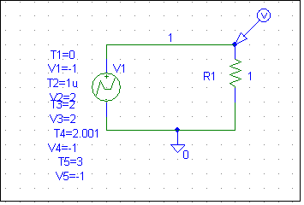
We use VPWL to enter in the signal as shown. In the transient dialog box, we enable Fourier, select 15 for Final Time, 0.01s for Print Step, and 10ms for the Step Ceiling. When the file is saved and run, we obtain the Fourier coefficients as part of the output file as shown below.
Why is this problem wrong? Clearly the source is not periodic. The DC value must be +1!!!!!!!!!!

FOURIER COMPONENTS OF TRANSIENT RESPONSE V(1)

DC COMPONENT = -1.000000E+00

HARMONIC FREQUENCY FOURIER NORMALIZED PHASE NORMALIZED
NO (HZ) COMPONENT COMPONENT (DEG) PHASE (DEG)

1 3.330E-01 1.615E-16 1.000E+00 1.762E+02 0.000E+00
2 6.660E-01 5.133E-17 3.179E-01 2.999E+01 -3.224E+02
3 9.990E-01 6.243E-16 3.867E+00 6.687E+01 -4.617E+02
4 1.332E+00 1.869E-16 1.158E+00 7.806E+01 -6.267E+02
5 1.665E+00 6.806E-17 4.215E-01 1.404E+02 -7.406E+02
6 1.998E+00 1.949E-16 1.207E+00 -1.222E+02 -1.179E+03
7 2.331E+00 1.465E-16 9.070E-01 -4.333E+01 -1.277E+03
8 2.664E+00 3.015E-16 1.867E+00 -1.749E+02 -1.584E+03
9 2.997E+00 1.329E-16 8.233E-01 -9.565E+01 -1.681E+03

